Chapter 13
Formatting Web Application Output
About This Chapter
ASP.NET provides two complementary ways for you to format output in a Web application:
- Use cascading style sheets (CSS) to control the appearance of elements on a Web form.
These styles can set the color, size, font, and behavior of the HTML elements on a Web page.
- Use Extensible Stylesheet Language Transformations (XSLT) to convert information from an Extensible Markup Language (XML) file to HTML output and position that information on a Web form.
XSLT puts data from the XML file into HTML elements and applies styles to those elements.
In this chapter, you’ll learn when and how to use each of these formatting techniques within a Web application.
Before You Begin
To complete this chapter, you must:
- Know how to create Web forms using HTML mode within Microsoft Visual Studio .NET.
- Be familiar with the HTML elements used to create Web forms and HTML pages.
Lesson 1: Using Cascading Style Sheets
Cascading style sheets (CSS) collect and organize all of the formatting information applied to HTML elements on a Web form. Because they keep this information in a single location, style sheets make it easy to adjust the appearance of Web applications.
Visual Studio .NET includes style-editing tools, along with a default style sheet that is created as part of new Web application projects. In this lesson, you’ll learn how to use the Visual Studio .NET tools to modify the default style sheet, attach the sheet to Web forms, and switch between style sheets at run time.
After this lesson, you will be able to
- Explain how Microsoft ASP.NET applies styles defined at different levels within a Web form
- Attach a style sheet to a Web form
- Modify styles within a style sheet
- Create new styles and add them to a style sheet
- Create style classes that can be applied to different types of HTML elements
- Change style sheets at run time to provide an enlarged-type version of a Web form or to format a Web form for printing
- Use behaviors to control dynamic elements on a Web form
Estimated lesson time: 35 minutes
How Styles Work
As mentioned in the opening of this lesson, style sheets store formatting in a single location: the CSS file. However, formatting can be applied at three different levels within a Web application. Before you start working with style sheets, you should understand how styles defined at different levels affect formatting. Table 13-1 describes these levels and how they apply to the elements on a Web form.
Table 13-1. Levels of Style
Level | Defined in | Applies to
Global | The style sheet file | All pages referencing the style sheet
Page | The page’s head element | All elements on the current page
Inline | The HTML element itself | Only the current element
These three levels follow precedence rules that are similar to the levels of scoping you’re already familiar with as a programmer. Inline formatting takes precedence over local formatting, which, in turn, takes precedence over global formatting. These precedence rules are the reason style sheets are referred to as cascading. Figure 13-1 illustrates how styles defined at different levels are applied to a paragraph element.
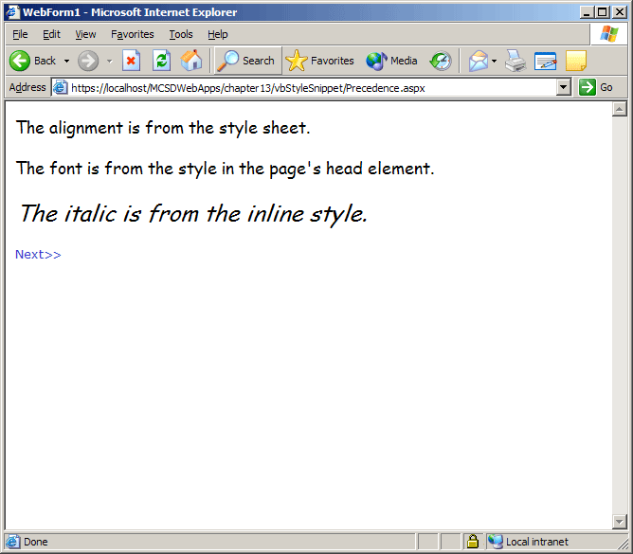
Figure 13-1. Style precedence
The following HTML shows the style definitions used to create the output shown in Figure 13-1:
<HTML>
<HEAD>
<title>WebForm1</title>
<!-- (1) Style sheet reference. -->
<LINK REL="stylesheet" TYPE="text/css" HREF="Styles.css">
<!-- (2) Page-level style definition. -->
<style>
p {
font-family: 'Comic Sans MS', Lucida Sans, sans-serif;
font-size: medium;
}
</style>
</HEAD>
<body>
<p>The alignment is from the style sheet.</p>
<p>The font is from the style in the page's head element.</p>
<!-- (3) Inline style definition -->
<p style="FONT-SIZE: large; FONT-STYLE: italic">The italic is from
the inline style.</p>
</body>
</HTML>

<!-- (1) From Styles.css style sheet referenced in HEAD element. -->
p
{
font-size: small;
text-align: center;
}
The preceding example shows how style attributes can be applied to a single element at different levels. The font-size attribute is applied at all three levels, but you see only the effects of the page level and inline settings because the page setting takes precedence over the style sheet setting. The text-align, font-family, and font-style attributes are each defined only once, so their effects are additive.
There are a couple of advantages to storing style definitions in a style sheet file (.css) rather than locally in each Web form or inline with each HTML element:
- Formatting can be maintained in one location so that you make changes only once for an entire application.
- Several sets of parallel formatting rules can be maintained in separate style sheets for formatting output on different devices or for different user needs. For example, an application might provide standard, enlarged-type, and printer-friendly style sheets that the user can select at run time.
TIP
In general, you should use page and inline styles only when you have a really good reason to override the global styles. Relying heavily on page and inline styles can make it difficult to maintain the formatting in a Web application.
Using Style Sheets with Web Forms
When you create a new Visual Basic .NET Web application, Visual Studio .NET automatically creates a style sheet named Styles.css for the application. However, Visual Studio .NET does not automatically use that style sheet in any of the Web forms or HTML pages you create.
To use that style sheet, you must add a link element to the page’s head element, as shown here in boldface:
<HEAD>
<title>WebForm1</title>
<meta name="GENERATOR" content="Microsoft Visual Studio.NET 7.0">
<meta name="CODE_LANGUAGE" content="Visual Basic 7.0">
<meta name="vs_defaultClientScript" content="JavaScript">
<meta name="vs_targetSchema" content="http://schemas.microsoft.com/intellisense/ie5">
<LINK REL="stylesheet" TYPE="text/css" HREF="Styles.css"></HEAD>
IMPORTANT
Only Microsoft Visual Basic .NET projects are created with a new default style sheet. For Microsoft Visual C# projects, you must create a new style sheet from scratch or cut and paste the contents of a default style sheet from a Visual Basic .NET project to get started.
Modifying Styles
Use the Style Builder to change the appearance of any of the styles in a style sheet. Changes to the style sheet change the appearance of all Web forms that reference that style sheet.
To modify a style, follow these steps:
- Open the style sheet in Visual Studio. Visual Studio .NET displays the style definitions in the Document window and an outline of the style sheet in the Tool window, as shown in Figure 13-2.
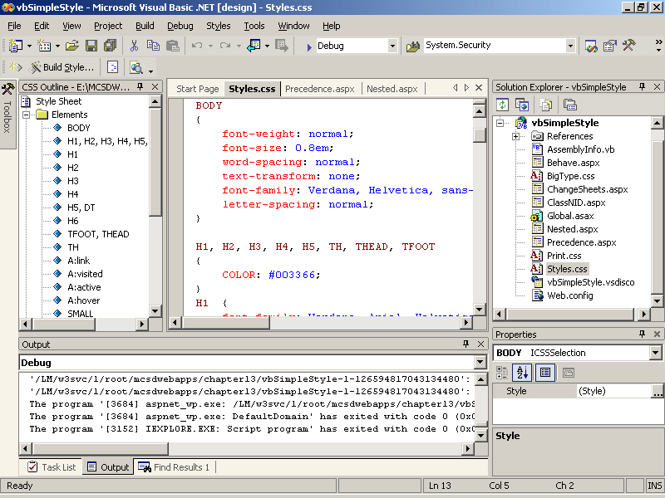
Figure 13-2. Style sheet Document and Tool windows
- Select the style to modify from the Tool window. Visual Studio .NET displays the definition for that style in the Document window.
- Right-click in the style definition or right-click the style in the Tool window, and select Build Style from the shortcut menu. Visual Studio .NET displays the Style Builder Wizard, as shown in Figure 13-3.
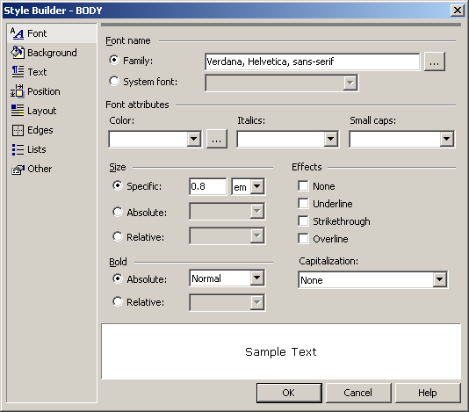
Figure 13-3. Style Builder
- Use the Style Builder to compose the formatting that you want to add or modify in the selected style, and then click OK.
When you have finished, you’ll see that the Style Builder adds the new or modified style attributes to the style definition.
Adding Styles
So far, we have created applied styles using HTML element names. CSS uses the element name to locate the default formatting to apply to each element. However, you can also apply styles using class names or element IDs.
Using class names allows you to apply a single style to a number of different elements or to style the same element differently, depending on how the element is used. Using element IDs allows you to apply a style to a unique element on one or more Web forms.
To add a style, follow these steps:
- Open the style sheet. Right-click the style sheet’s Document or Tool window, and select Add Style Rule from the shortcut menu. Visual Studio .NET displays the Add Style Rule Wizard, as shown in Figure 13-4.
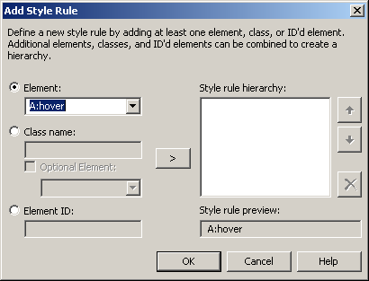
Figure 13-4. Add a style
- Select the type of style you want to create. You can create styles that apply to HTML elements, classes, or specific element IDs. Type the name of the item to create the style for and click the > (Add) button to add the item to the style rule.
- Repeat step 2 for each item you want the style to apply to.
Using Style Classes
Style classes allow you to apply the same formatting to different HTML elements on a Web form. When you create a style rule for a class, Visual Studio .NET adds a style definition to the style sheet using a .classname identifier, as shown here:
.emphasis
{
font-style: italic;
}
The preceding .emphasis style class formats all elements that use the class in italic, as shown in Figure 13-5.
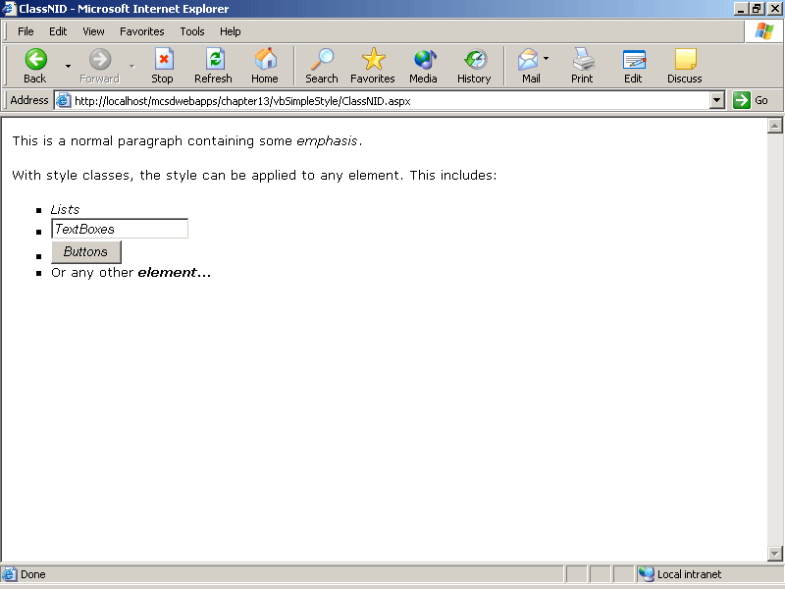
Figure 13-5. Applying a style class
You apply the style class to HTML elements by using the class attribute. You apply the style to server controls by using the CssClass attribute. The following HTML shows this difference in boldface:
<p>This is a paragraph containing <span class="emphasis">emphasis</span>.</p>
<asp:TextBox ID="Text1" Runat="server" CssClass="emphasis">Some text
</asp:TextBox>
Creating Styles for Specific Elements
You can also create styles for specific elements on a Web form based on their element IDs. Element IDs must be unique for each element on a page, so formatting set by element ID can apply to only one element on each page. When you create a style rule for an element ID, Visual Studio .NET adds a style definition to the style sheet using a #elementID identifier, as shown here:
#inserted
{
text-decoration: underline;
}

#deleted
{
text-decoration: line-through;
}
The preceding style definitions format elements with the ID inserted as underlined text and elements with the ID deleted with strikethrough, as shown in Figure 13-6.
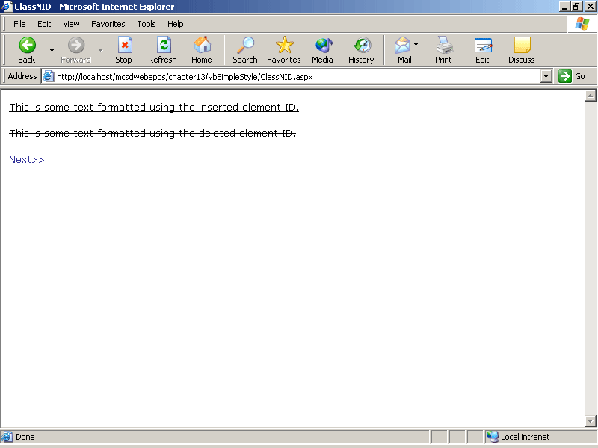
Figure 13-6. Applying a style by element ID
Styles applied in Visual Studio .NET don’t always show up right away in the Web Forms Designer. If you’re not seeing the formatting applied through a particular style, try the following:
- Make sure the style sheet has been saved.
- Switch the Web form between HTML view and the Design view.
- Right-click the Web form, and select View In Browser from the shortcut menu.
Creating Nested Styles
If you look at the style definitions in the default style sheet, Styles.css, you’ll notice that some style definitions list multiple element names. These definitions establish which formatting to use for nested elements. For example, the following styles specify different bullet types for nested, unnumbered lists:
UL LI {
list-style-type: square ;
}

UL LI LI {
list-style-type: disc;
}

UL LI LI LI {
list-style-type: circle;
}
The preceding nested files format the nested list items, as shown in Figure 13-7.
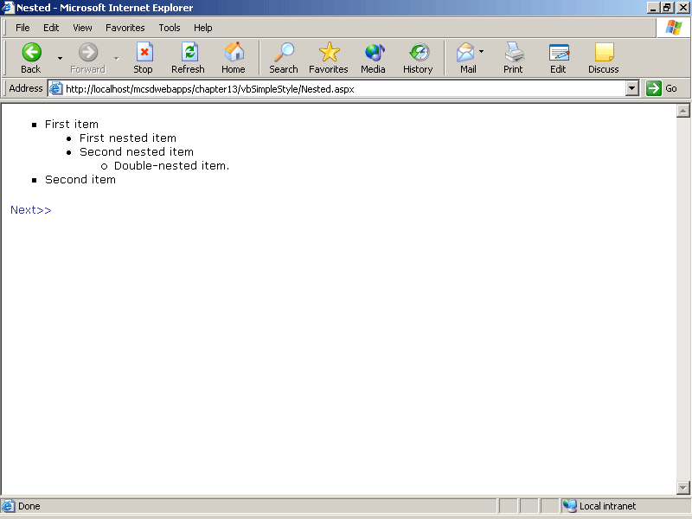
Figure 13-7. Nested list
To create your own nested styles, add multiple items to the Style rule hierarchy in the Add Style Rule dialog box, as shown in Figure 13-8.
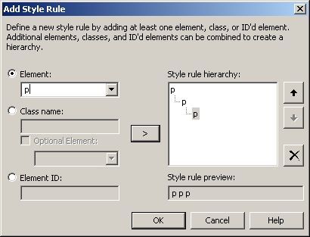
Figure 13-8. Creating nested styles
Changing Style Sheets at Run Time
As mentioned, you can create multiple style sheets and then allow the user to select the styles to use at run time to format the Web form for printing or to provide features such as enlarged-type versions of Web forms.
To switch style sheets automatically when printing a Web form, use the media attribute of the style sheet link element to specify the style sheet to use for printing and screen display. For example, the following link elements apply formatting from the default style sheet when the Web form is displayed on screen, but they use the Print.css style sheet when the user prints the Web form:
<LINK REL="stylesheet" TYPE="text/css" HREF="Styles.css" media="screen">
<LINK REL="stylesheet" TYPE="text/css" HREF="Print.css" media="print">
To switch between style sheets at run time, create a client-side script to change the href element of the style sheet link element. For example, the following HTML creates a Web form that switches between the style sheets Styles.css and BigType.css when the user clicks a hyperlink in text:
VBScript
<HTML>
<HEAD id="myhead">
<title>ChangeSheets</title>
<LINK ID="ScreenStyle" REL="stylesheet" TYPE="text/css" HREF="Styles.css">
<script language="vbscript">
' VBScript
' Switch between default and large-type style sheets.
Sub SwitchSheets()
If document.all("ScreenStyle").GetAttribute("HREF") = "Styles.css" then
document.all("ScreenStyle").SetAttribute "HREF", "BigType.css", 0
else
document.all("ScreenStyle").SetAttribute "HREF", "Styles.css", 0
end if
End Sub
</script>
</HEAD>
<body>
<form id="Form1" method="post" runat="server">
<h2>Changing Style Sheets at Run-Time</h2>
<p>This page first appears using the default style sheet.</p>
<p><a onclick="SwitchSheets" href="#">Click here
</a> to switch between the standard and the enlarged-type version.</p>
</form>
</body>
</HTML>
JScript
<HTML>
<HEAD>
<title>ChangeSheets</title>
<LINK ID="ScreenStyle" REL="stylesheet" TYPE="text/css"
HREF="Styles.css" media="screen">
<LINK ID="PrintStyle" REL="stylesheet" TYPE="text/css"
HREF="Print.css" media="print">
<script id=clientEventHandlersJS language=jscript>
function SwitchSheets()
{
// Switch between default and large-type style sheets.
if (document.all["ScreenStyle"].getAttribute("HREF") == "Styles.css")
document.all["ScreenStyle"].setAttribute ("HREF",
"BigType.css", 0);
else
document.all["ScreenStyle"].setAttribute ("HREF", "Styles.css", 0);
}
</script>
</HEAD>
<body MS_POSITIONING="FlowLayout">
<FORM id="Form1" method="post" runat="server">
<H2>Changing Style Sheets at Run-Time</H2>
<P>This page first appears using the default style sheet.</P>
<P><A onclick="SwitchSheets();" href="#">Click here</A>
to switch between the standard and
the enlarged-type version.</P>
<A href="Behave.aspx">Next&gt;&gt;</A>
</FORM>
</body>
</HTML>
Figure 13-9 shows the how the Web form changes at run time when the user changes the style sheets by clicking the link.
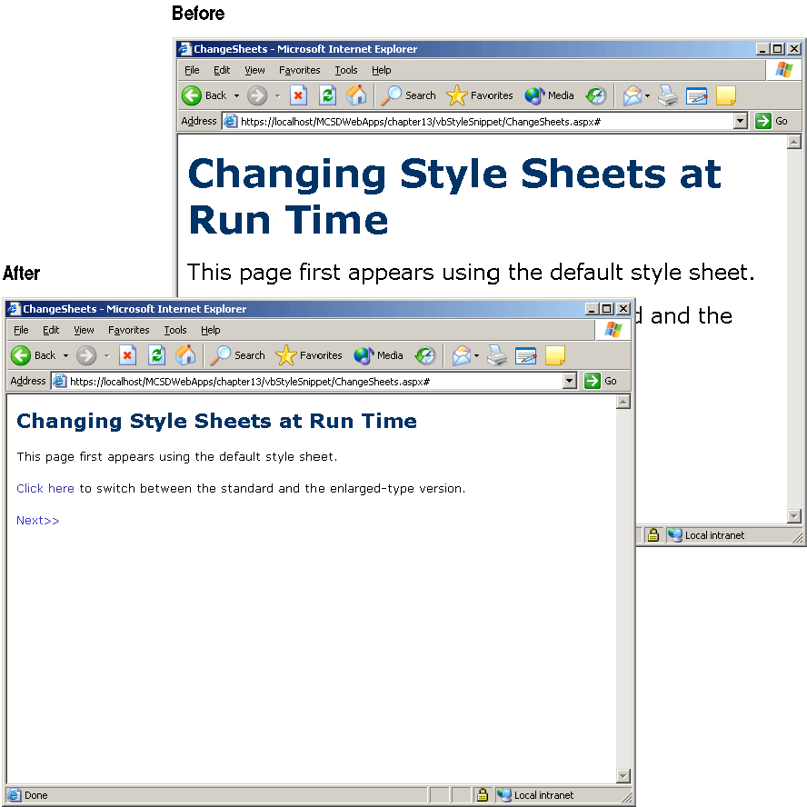
Figure 13-9. Changing style sheets at run time
Using Behaviors
In addition to formatting, styles can also define behaviors that HTML elements exhibit at run time. Behaviors are a sort of dynamic formatting: because Web content isn’t always static, style sheets use behaviors to describe dynamic changes.
For example, HTML+TIME animations use the time class to apply animations to HTML elements on a page, as shown here:
<style>
.time {behavior: url(#default#time2);}
</style>
The behavior property imports behavior files that contain Microsoft JScript or Microsoft Visual Basic Scripting Edition (VBScript) code that controls what the behavior does. The Behaviors Library topic in the Visual Studio .NET online Help provides a number of sample behaviors that you can download and use in your own code.
For example, the following HTML imports the Movable.htc sample behavior file and uses it to create a paragraph that the user can drag to a new location on the Web form at run time:
<HEAD>
<title>Behave</title>
<style>
.movable {behavior: url(behaviors/movable.htc); CURSOR: move;
mv--boundary: 0 800 600 0}
</style>
</HEAD>
<body>
<form id="Form1" method="post" runat="server">
<p class="movable">You can drag this text around the screen.</p>
</form>
</body>
</HTML>
In the preceding HTML, the style definition for the movable class includes the URL of the behavior file, the cursor style to use, and the boundaries the elements are confined to. The style is applied by the p element’s class attribute. At run time, the user can drag the paragraph around the screen, as shown in Figure 13-10.
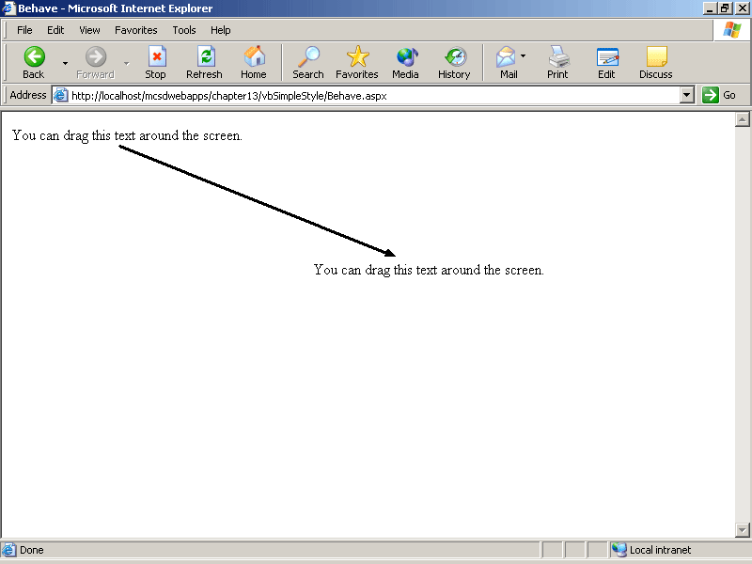
Figure 13-10. The movable behavior
The movable behavior can be applied to any element on a Web form, including server controls. Some behaviors, however, can be applied only to certain types of controls. For instance, the ColorPick behavior shown in the following code can be applied only to HTML Text Field controls (input elements of type text):
<HTML xmlns:control>
<HEAD>
<title>Behave</title>
<style>
.color { BEHAVIOR: url(behaviors/ColorPick.htc) }
</style>
</HEAD>
<body>
<form id="Form1" method="post" runat="server">
<p>Use the color picker below to change the background color:</p>
<input ID="ColorPic" type="text" class="color" value="#fFFf00"
onchange="document.bgColor=ColorPic.value;" style="cp--grid-size:2">
</form>
</body>
</HTML>
The preceding HTML displays a color palette that the user can click to change the background color at run time, as shown in Figure 13-11.
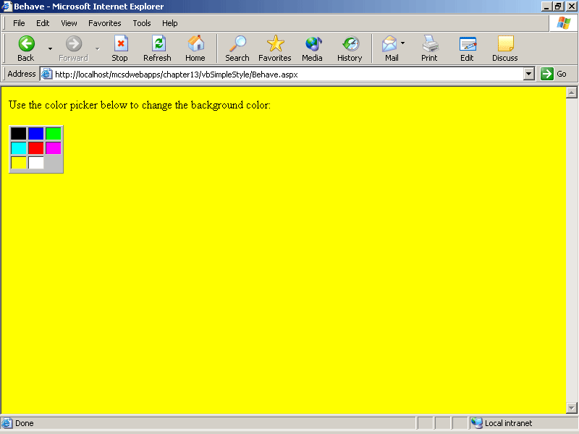
Figure 13-11. The ColorPick behavior
Finally, some behaviors create their own types of elements that you can use on a Web form. For example, the Slider sample behavior creates a slider element that you can use to get input from a user. To use the Slider control, you must first add an xmlns attribute to the Web form’s html element to declare the name for the control, as shown here:
<HTML xmlns:control>
<HEAD>
<title>Behave</title>
<style>
control\:slider { BEHAVIOR: url(behaviors/slider.htc) }
</style>
</HEAD>
<body>
<form id="Form1" method="post" runat="server">
<control:slider ID="Slider" onchange="alert(Slider.value)"
STYLE="sl--orientation:horizontal"></control:slider>
</form>
</body>
</HTML>
The preceding HTML creates a Slider control that displays the control’s value when the user slides the control on a Web form, as shown in Figure 13-12.
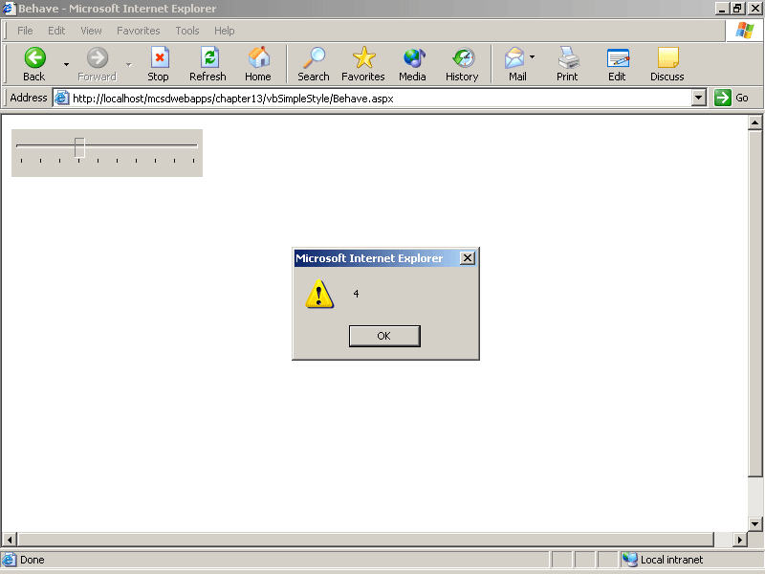
Figure 13-12. The Slider behavior
IMPORTANT
Although you can use behaviors that create controls on Web forms, it’s usually a better idea to create and use custom controls for tasks that aren’t handled by the standard server and HTML controls. Controls created by behaviors are not displayed correctly in the Visual Studio .NET Designer window and don’t provide properties and methods that are readily available from server-side code. Custom controls provide both of these advantages.
Lesson 2: Using XSL Transformations
In this lesson, you’ll learn about using XSL to transform XML files, using expressions written in XML path language (XPath).
After this lesson, you will be able to
- Use the XML control to transform an XML data file into formatted HTML on a Web form
- Explain the differences between XML and HTML
- Create an XML file
- Create XSL templates to control how the XML file is transformed into HTML
- Use the XSL elements to repeat tasks, perform conditional operations, insert HTML elements, and sort output
- Evaluate expressions using XPath
Estimated lesson time: 40 minutes
How XSL Transformations Work
XSL transformations use the XML server control to generate formatted output from an XML input file using a set of rules stored in an XSL description file. The XSL file is similar to the CSS file you learned about in the preceding lesson—it provides the formatting rules that are applied to the output displayed on the Web form. Unlike CSS files, however, XSL files can position elements anywhere on the Web form and can perform logical operations, such as repeating and conditional operations.
You can think of XSL files as an intelligent formatting layer that complements—rather than replaces—CSS. Use XSL to place structured data on a Web form, and then use CSS to set the appearance of the elements within that layout.
To perform an XSL transformation on a Web form, follow these steps:
- Add an XML server control to a Web form.
- Set the control’s DocumentSource property to the XML file to format.
- Set the TransformSource property to the XSL file to use to format the output.
At run time, the XML server control processes the XML input using the XSL description to provide formatted output, as shown in Figure 13-13.
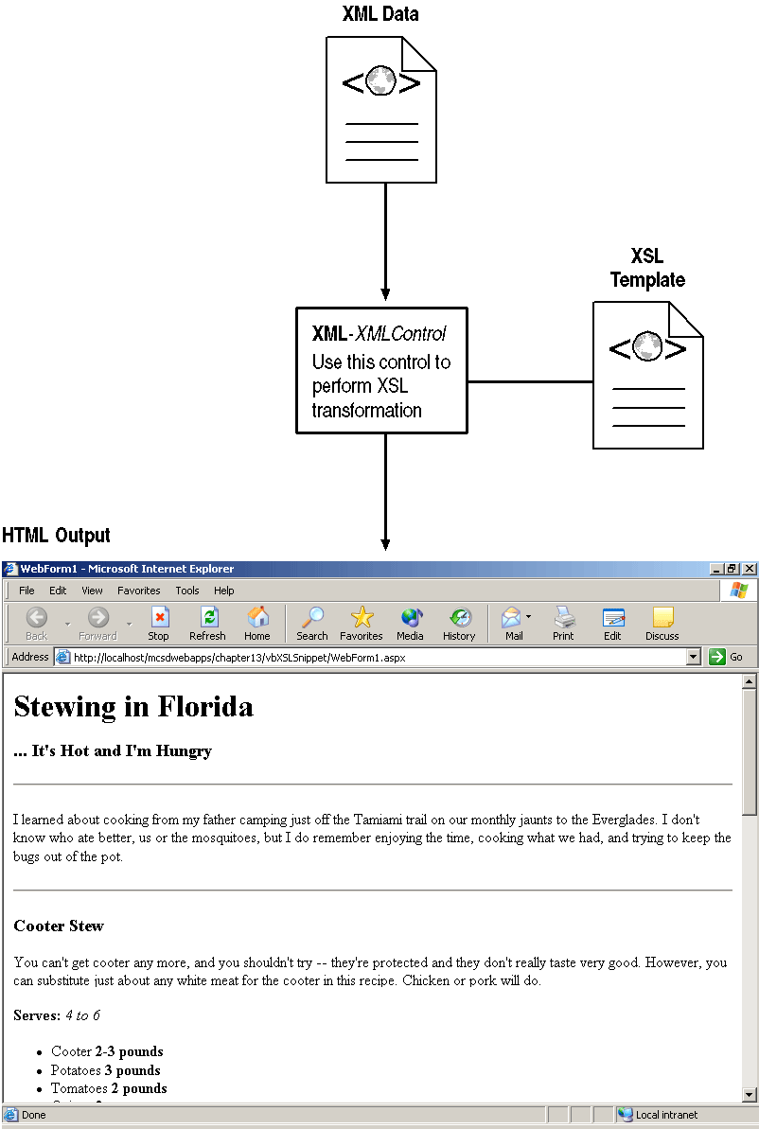
Figure 13-13. Performing XSL transformation
Creating an XML File
XML files are a way to describe structured data in text format. XML identifies data items using <element>…</element> tags much the same as HTML. Unlike HTML, however, the rules of XML are strict:
- Each item must have a begin tag and an end tag.
In HTML, <li>, <br>, and other tags can exist without equivalent </li> or </br> tags. That is not allowed in XML.
- Item tag names are case sensitive.
In HTML, <P> and <p> are equivalent. In XML, they constitute different tags.
- Attribute values must always be enclosed in double quotation marks.
In HTML, you can omit quotation marks for numeric attributes such as <table cols=3>. In XML, you must always include the quotation marks: <table cols="3">.
- The nested items must be terminated before the containing item is terminated.
For example, the following is OK in HTML: <b>Bold text<i>italic bold</b> regular italic</i>. However, in XML it must be written like this: <b>Bold text<i>italic bold</i></b> <i>regular italic</i>
These strict rules allow XML to have an important capability that HTML does not have: in XML, you can define your own tags, and you can assign those tags any meaning you choose.
To create an XML file in Visual Studio .NET, choose Add New Item from the Project menu, choose XML file from the Templates list, and then click Open.
When you create a new XML file, it’s a good idea to first write out the tags and structure that you’ll use throughout the document. This saves you the trouble of trying to retag elements if you discover that you missed something. For example, the following XML describes cookbook data that we’ll be using as a sample in this lesson:
<cookbook>
<title></title>
<subtitle></subtitle>
<description></description>
<recipe>
<title></title>
<subtitle></subtitle>
<description></description>
<servings></servings>
<ingredients>
<ingredient>
<name></name>
<quantity></quantity>
</ingredient>
<ingredient>
<name></name>
<quantity></quantity>
</ingredient>
</ingredients>
<instructions>
<introduction></introduction>
<step></step>
<step></step>
<step></step>
<summary></summary>
</instructions>
</recipe>
</cookbook>
The data for each of these items will go between each of the begin and end tags. What’s important to notice at this point is the structure of the file and that the element names describe the content of the element, rather than its formatting. By labeling the content, you can apply content-based formatting using XSL.
The XML structure is strictly hierarchical. XML refers to the items in this hierarchy as XML nodes. Nodes have parent-child relationships that are identified using the XPath, as shown in Figure 13-14.
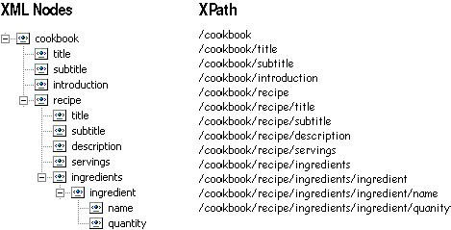
Figure 13-14. XML nodes
XML is well suited for structured data such as stock quotes, employee information, product inventory, order status, and other data that we’re used to dealing with in an organized fashion. XML is not as well suited for information that uses creative or ad hoc organization.
Creating an XSL File
The XSL file provides the layout and logic that transforms data stored in the XML file into the output you see on the Web form. To create an XSL file in Visual Studio, choose Add New Item from the Project menu, choose XSLT File from the Templates list, and then click Open.
The XSL file contains template statements that select the items to import from the XML file. Each template includes standard HTML elements to apply formatting to the elements imported from the XML file. For example, the following XSL template converts cookbook title, subtitle, and introduction elements from an XML file to h1, h2, and p elements in HTML:
<?xml version="1.0" encoding="UTF-8" ?>
<xsl:stylesheet version="1.0" xmlns:xsl="http://www.w3.org/1999/XSL/Transform">
<xsl:template match="/cookbook">
<xsl:apply-templates select="cookbook" />
<h1><xsl:value-of select="title" /></h1>
<h3><xsl:value-of select="subtitle" /></h3>
<hr />
<p><xsl:value-of select="introduction" /></p>
<hr />
<h2><xsl:text>Recipes</xsl:text></h2>
<xsl:apply-templates select="recipe" />
</xsl:template>
</xsl:stylesheet>
The preceding example uses the XSL elements and attributes summarized in Table 13-2.
Table 13-2. Basic XSL Elements
Element | Attributes | Use to
xsl:stylesheet | version | Identify the version of XSL being used. Version 1.0 is the current version at the time of this writing.
 | xmlns:xsl | Specify the prefixes for elements in the XSL file.
xsl:template | match | Define a template for an XML node.
xsl:apply-templates | select | Apply a template to the selected node.
xsl:value-of | select | Retrieve the value of an XML node or evaluate an XPath expression.
xsl:text |  | Include literal text or white space characters in the output.
Figure 13-15 shows how these elements work to transform cookbook XML data through the XML server control.
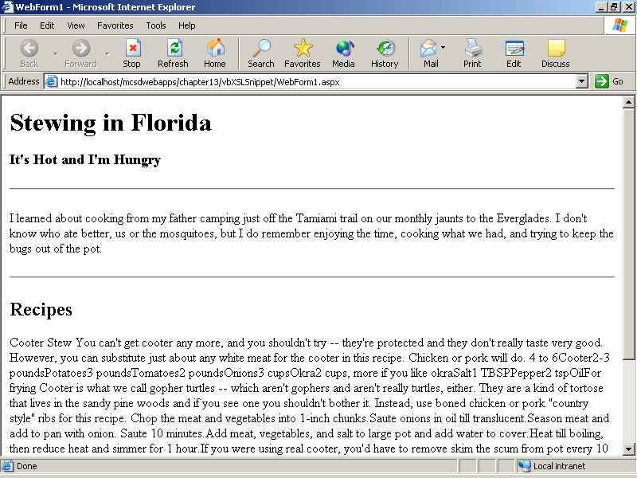
Figure 13-15. Basic XSL elements in action
The XSL elements demonstrated in Figure 13-15 perform the minimum tasks for displaying data with XSL: they define a template, import data into that template, display values from the XML, and insert literal text. Those are all tasks that are more easily performed simply by using regular HTML and style sheets. However, using XSL offers two advantages:
- You can change the position of the element (page layout) in the XSL file without having to change your data.
- You can perform logical operations on data, such as looping and conditional processing.
These advantages are discussed in the following sections.
Changing Layout
You change page layout in XSL by moving elements in the XSL file. For example, the following XSL displays the cookbook XML in a two-column format and displays the subtitle before the title:
<?xml version="1.0" encoding="UTF-8" ?>
<xsl:stylesheet version="1.0" xmlns:xsl="http://www.w3.org/1999/XSL/Transform">
<xsl:template match="/cookbook">
<xsl:apply-templates select="cookbook" />
<table>
<tr>
<td width="300">
<h3><xsl:value-of select="subtitle" />
<xsl:text>...</xsl:text></h3>
<h1><xsl:value-of select="title" /></h1>
</td>
<td width="500">
<xsl:text>recipe text goes here..</xsl:text>
</td>
</tr>
<tr>
<td width="300">
<hr />
<xsl:value-of select="introduction" />
<hr />
</td>
<td width="500">
</td>
</tr>
</table>
</xsl:template>
</xsl:stylesheet>
Figure 13-16 shows the changes to the output on the Web form.
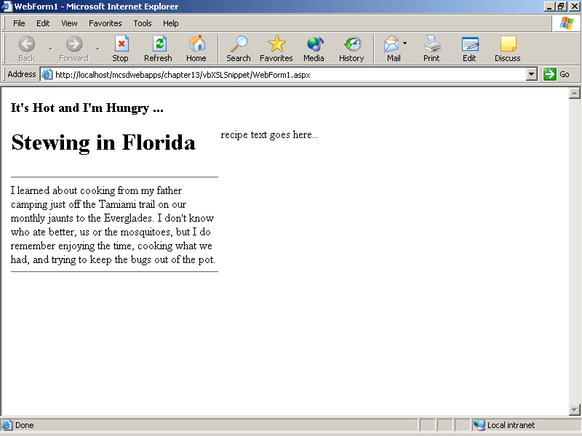
Figure 13-16. Changing layout with XSL
Including Other Templates
An XSL file can contain multiple templates. You define an XSL template for each XML node that is uniquely formatted. For example, the cookbook XML shown earlier in this lesson could be organized into four templates:
- The main template formats the title and description of the book and provides a starting point. XSL execution starts with this template because it selects the root node (match="/ cookbook”).
- The recipe template formats the recipes included in the book.
- The ingredients template formats the list of ingredients.
- The instructions template formats the steps that follow the list of ingredients.
Use the xsl:apply-templates element to apply a template to a node. For example, the following XSL applies the ingredient and instruction templates from the recipe template, which is in turn applied from the main template. The links between the templates are shown in boldface:
<?xml version="1.0" encoding="UTF-8" ?>
<xsl:stylesheet version="1.0" xmlns:xsl="http://www.w3.org/1999/XSL/Transform">

<xsl:template match="/cookbook">
<xsl:apply-templates select="cookbook" />
<h1><xsl:value-of select="title" /></h1>
<h3><xsl:text>...</xsl:text><xsl:value-of select="subtitle" /></h3>
<hr />
<p><xsl:value-of select="introduction" /></p>
<hr />
<xsl:apply-templates select="recipe" /> </xsl:template>

<xsl:template match="recipe">
<h3><xsl:value-of select="title" /></h3>
<p><xsl:value-of select="description" /></p>
<p><b><xsl:text>Serves: </xsl:text></b>
<i><xsl:value-of select="servings" /></i></p>
<xsl:apply-templates select="ingredients" />
<xsl:apply-templates select="instructions" /> </xsl:template>

<xsl:template match="ingredients">
<ul>
<li><xsl:value-of select="ingredient/name" />
<xsl:text> </xsl:text>
<b><xsl:value-of select="ingredient/quantity" /></b></li>
</ul>
</xsl:template>

<xsl:template match="instructions">
<p><xsl:value-of select="introduction" /></p>
<ol>
<li><xsl:value-of select="step" /></li>
</ol>
<p><xsl:value-of select="summary" /></p>
</xsl:template>

</xsl:stylesheet>
At run time, the preceding XSL template creates HTML output, as shown in Figure 13-17.
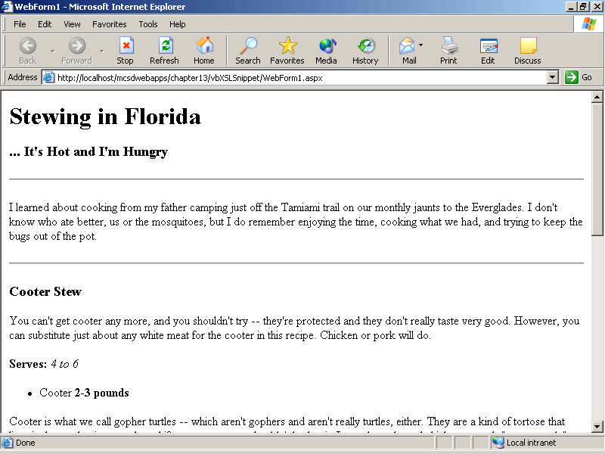
Figure 13-17. Using multiple templates together
But wait! There’s only one ingredient (cooter) and one instruction (cut it up). As the templates are written, they process only one node each. To repeat tasks, you need to use the XSL looping elements, as described in the following section.
Repeating Tasks
To format repeating elements in an XML file, such as list or table items, use the xsl:for-each XSL element. The xls:for-each element selects the repeated node, and then the contained XSL is applied to each occurrence of that node, as shown here:
<xsl:for-each select="ingredient">
<xsl:value-of select="name" /><br />
</xsl:for-each>
The preceding XSL outputs the name of each repeated ingredient node. To refer to the repeated node itself, use the "." XPath identifier. For example, the following XSL outputs the text of each repeated step node in the XML:
<xsl:for-each select="step">
<xsl:value-of select="." /><br />
</xsl:for-each>
The following XSL uses the xsl:for-each element (shown in boldface) to display all of the recipes, ingredients, and steps in the cookbook:
<?xml version="1.0" encoding="UTF-8" ?>
<xsl:stylesheet version="1.0" xmlns:xsl="http://www.w3.org/1999/XSL/Transform">

<xsl:template match="/cookbook">
<xsl:apply-templates select="cookbook" />
<h1><xsl:value-of select="title" /></h1>
<h3><xsl:text>...</xsl:text><xsl:value-of select="subtitle" /></h3>
<hr />
<p><xsl:value-of select="introduction" /></p>
<hr />
<xsl:for-each select="recipe">
<xsl:apply-templates select="." />
</xsl:for-each> </xsl:template>

<xsl:template match="recipe">
<h3><xsl:value-of select="title" /></h3>
<p><xsl:value-of select="description" /></p>
<p><b><xsl:text>Serves: </xsl:text></b>
<i><xsl:value-of select="servings" /></i></p>
<xsl:apply-templates select="ingredients" />
<xsl:apply-templates select="instructions" />
</xsl:template>

<xsl:template match="ingredients">
<ul>
<xsl:for-each select="ingredient">
<li><xsl:value-of select="name" />
<xsl:text> </xsl:text>
<b><xsl:value-of select="quantity" /></b></li>
</xsl:for-each> </ul>
</xsl:template>

<xsl:template match="instructions">
<p><xsl:value-of select="introduction" /></p>
<ol>
<xsl:for-each select="step">
<li><xsl:value-of select="." /></li>
</xsl:for-each> </ol>
<p><xsl:value-of select="summary" /></p>
</xsl:template>

</xsl:stylesheet>
At run time, the preceding XSL formats the cookbook XML, as shown in Figure 13-18.
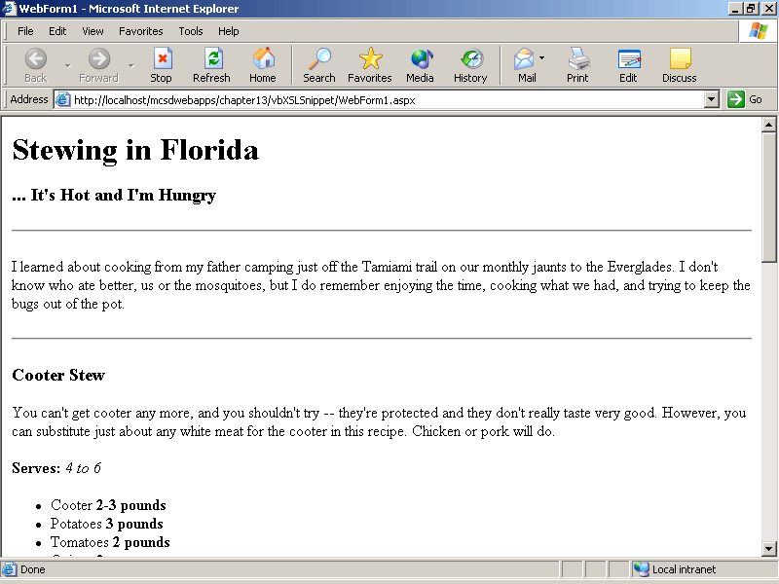
Figure 13-18. Formatting repeated elements
Inserting Hyperlinks and Other HTML Elements
Use xsl:element to compose HTML elements that contain attributes, such as hyperlinks, server controls, or HTML controls. For example, the following XSL creates a hyperlink that returns the user to the top of the page:
<xsl:element name="a">
<xsl:attribute name="name">
<xsl:text>#top</xsl:text>
</xsl:attribute>
<xsl:text>Return to top.</xsl:text>
</xsl:element>
At run time, the preceding XSL generates the following output:
<a href="#top">Return to top.</a>
You can couple this XSL with the XPath generate-id function to automatically create a table of contents for your document that links to locations within a document, as shown in boldface in the following XSL:
<xsl:template match="/cookbook">
<h1><xsl:value-of select="title" /></h1>
<h3><xsl:text>...</xsl:text><xsl:value-of select="subtitle" /></h3>
<hr />
<p><xsl:value-of select="introduction" /></p>
<hr />
<!-- Display table of contents -->
<h4>Contents</h4>
<xsl:apply-templates mode="contents" select="recipe" /> <xsl:for-each select="recipe">
<xsl:apply-templates select="." />
</xsl:for-each>
</xsl:template>

<xsl:template match="recipe">
<!-- Create location links -->
<xsl:element name="a">
<xsl:attribute name="name">
<xsl:value-of select="generate-id(title)" />
</xsl:attribute>
<h3><xsl:value-of select="title" /></h3>
</xsl:element> <p><xsl:value-of select="description" /></p>
<p><b><xsl:text>Serves: </xsl:text></b>
<i><xsl:value-of select="servings" /></i></p>
<xsl:apply-templates select="ingredients" />
<xsl:apply-templates select="instructions" />
</xsl:template>

<xsl:template mode="contents" match="recipe">
<!-- Create table of contents links -->
<xsl:element name="a">
<xsl:attribute name="href">
<xsl:text>#</xsl:text>
<xsl:value-of select="generate-id(title)" />
</xsl:attribute>
<xsl:value-of select="title" />
</xsl:element> <br />
</xsl:template>
At run time, the preceding XSL generates the output shown in Figure 13-19.
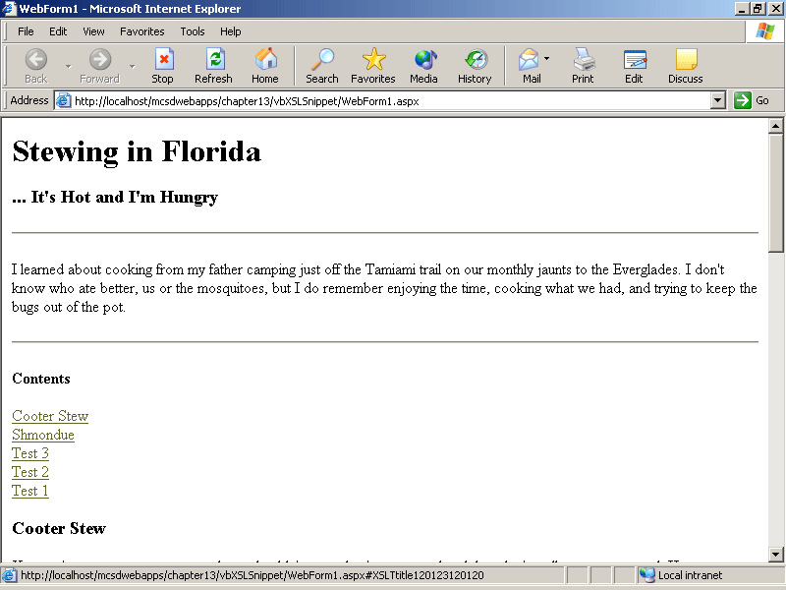
Figure 13-19. Generating a table of contents
The generate-id XPath function generates a unique ID for the XML node passed to it as an argument. The ID takes the form XSLTnodename#, where # is a 12-digit integer, as in this example: XSLTtitle120123120120.
Sorting Items
Use the xsl:sort element to sort items within another XSL element. For example, the following XSL sorts the table of contents created in the preceding section:
<h4>Contents</h4>
<xsl:apply-templates mode="contents" select="recipe">
<xsl:sort select="title" order="ascending" />
</xsl:apply-templates>
The xsl:sort element can be included in xsl:apply-templates elements, as shown in the preceding code, or in xsl:for-each elements.
Performing Conditional Tasks
XSL includes two sets of elements for performing conditional tasks: use xsl:if to evaluate a single condition; use xsl:choose with contained xsl:when and xsl:otherwise elements to evaluate multiple conditions. Table 13-3 summarizes these conditional elements.
Table 13-3. Conditional XSL Elements
Element | Attribute | Use to
xsl:if | test | Test a Boolean expression and process the contained elements if the result is true.
xsl:choose |  | Test multiple conditions using contained xsl:when and xsl:otherwise elements. This is the equivalent of a Select Case (Visual Basic .NET) or switch (Visual C#) statement.
xsl:when | test | Test one Boolean expression within an xsl:choose element, and then process the contained item and exit the xsl:choose element if the result is true. This is the equivalent of the Case (Visual Basic .NET) or case (Visual C#) statement.
xsl:otherwise |  | Process the contained item if none of the xsl:when elements within an xsl:choose element are true. This is the equivalent of the Case Else (Visual Basic .NET) or default (Visual C#) statement.
The conditional elements’ test attribute evaluates an XPath expression to determine whether the XSL contained in the conditional element should be processed. For example, the following XSL creates a table of contents if there are more than four recipes in the cookbook:
<xsl:if test="count(recipe) > 4">
<h4>Contents</h4>
<xsl:apply-templates mode="contents" select="recipe" />
</xsl:if>
The preceding XSL uses the XPath count function to return the number of recipe nodes in the cookbook. If the count is greater than 4, the Contents heading is output and the contents template is processed; otherwise, the contents are omitted.
Similarly, you can use XPath functions within xsl:choose elements to change output based on several conditions. For example, the following XSL inserts a line break after every four contents items; otherwise, it separates items with a tab space:
<xsl:template mode="contents" match="recipe">
<xsl:element name="a">
<xsl:attribute name="href">
<xsl:text>#</xsl:text>
<xsl:value-of select="generate-id(title)" />
</xsl:attribute>
<xsl:value-of select="title" />
</xsl:element>
<xsl:choose>
<xsl:when test="position() mod 4 = 0">
<br />
</xsl:when>
<xsl:otherwise>
<xsl:text> </xsl:text>
</xsl:otherwise>
</xsl:choose>
</xsl:template>
The preceding XSL uses the XPath position function to return the position of the current node within the node’s collection. It also uses the XPath mod operator to determine whether the current position is evenly divisible by four.
More Info
We’ve only scratched the surface of what you can do with XSL here. XML, XSL, and XPath are all languages in their own right. This lesson gives you enough information to get started, but for a complete education, see the Microsoft XML SDK documentation included in the Visual Studio .NET online Help. Microsoft Press books that cover this subject include XML Step by Step, Second Edition, by Michael J. Young, and XML Programming (Core Reference), by R. Allen Wyke, Sultan Rehman, and Brad Leupen.
Summary
- Styles follow this order of precedence based on where they are applied: local (applied to an element), page (applied within a page’s head element), and global (applied through a style sheet).
- Use the link element within a Web form’s head element to attach a style sheet.
- Use the Visual Studio .NET Style Builder Wizard to modify existing styles.
- Use the Visual Studio .NET Add Style Rule Wizard to create a new style.
- Create a style class to apply the same formatting to different types of elements.
- Use the CssStyle attribute to apply a style class to a server control. Use the class attribute to apply a style class to an HTML element.
- XSL transformations convert XML input files to HTML through the XML server control.
- XML organizes data into a hierarchical set of nodes.
- XSL templates apply formatting to nodes within an XML file.
- Use the xsl:value-of element to retrieve data from an XML node.
- Use the xsl:text element to include literal text and white-space characters in XSL output.
- Use the xsl:for-each element to repeat tasks for lists, tables, and other repeated nodes within an XML file.
- Use the xsl:if, xsl:choose, xsl:when, and xsl:otherwise elements to perform conditional processing within XSL.
Lab: Creating the Cookbook
In this lab, you’ll build a single Web form that uses a customized style sheet, provides an enlarged-type style sheet for visually impaired users, and uses XML with XSL transformations to format information. You’ll also be encouraged to apply your knowledge of XML to real-world data you’re already familiar with.
Estimated lesson time: 30 minutes
Exercise 1: Create and Attach a Style Sheet

Use the skills you learned in Lesson 1 to create your own style sheet based on the default style sheet Visual Studio .NET creates. Because style (and taste) are personal matters, you can make the changes suggested in the following steps, or you can develop your own unique look. When you have finished, your result might look similar to Figure 13-20.
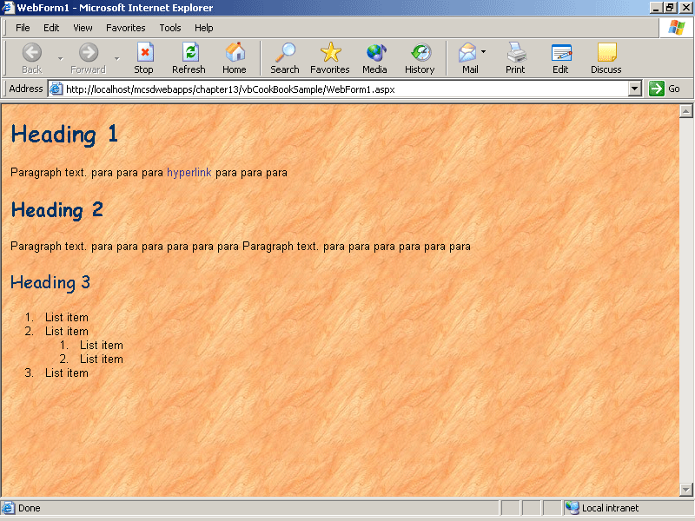
Figure 13-20. Test Web form with styles
To create a custom style sheet and attach it to a Web form
- Make the following suggested changes to the default style sheet (Styles.css), or choose your own changes:
  - Change the default font for all headings to Comic Sans MS.
  - Change the default font for body text to Lucida Sans-Serif.
  - Add a background image to the page from within the style sheet.
  - Change the color of the headings and rule lines to stand out against your chosen background image.
- When you have finished modifying the style sheet, attach it to a Web form by adding a link element in the Web form’s head element, as shown here in boldface:
- <HEAD>
- <meta name="GENERATOR" content="Microsoft Visual Studio.NET 7.0">
- <meta name="CODE_LANGUAGE" content="Visual Basic 7.0">
- <meta name="vs_defaultClientScript" content="JavaScript">
- <meta name="vs_targetSchema"
- content="http://schemas.microsoft.com/intellisense/ie5">
<LINK REL="stylesheet" TYPE="text/css" HREF="Styles.css"></HEAD>
- Add some sample text and headings to the Web form to test the appearance of your style sheet.
- View the Web form in the browser, and adjust the style sheet until you’re happy with the Web form’s appearance.
Exercise 2: Provide Alternative Style Sheets
In this exercise, you’ll create an alternative style sheet that displays headings and text in a larger font size, making your Web form readable for users with impaired vision. You’ll also add a client-side control that enables the user to switch to the large-type style sheet at run time. When you have finished, your result should look similar to Figure 13-21.
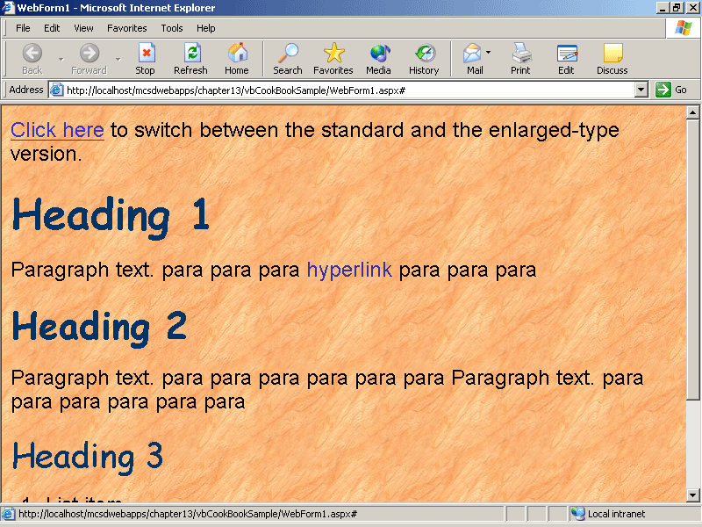
Figure 13-21. Enlarged-type sample
To create the enlarged-type style sample
- Add a new, empty style sheet to your project. Name the file BigType.css.
- Cut and paste the contents of the default style sheet (Styles.css) into BigType.css. If you’re using Visual C#, you’ll have to get the default style sheet from a Visual Basic .NET project and add it to your Visual C# project.
- In BigType.css, change the body element’s font size to large.
- On the Web form created in Exercise 1, add an ID and a media attribute to the link element that attaches the default style sheet to the Web form, as shown here in boldface:
<LINK ID="ScreenStyle" REL="stylesheet" TYPE="text/css" HREF="Styles.css" media="screen">
- Add another link element to use the default style sheet for printing, as shown here:
<LINK ID="PrintStyle" REL="stylesheet" TYPE="text/css" HREF="Styles.css" media="print">
- Add a hyperlink with an onclick event to switch between the default style sheet and BigType.css, as shown here:
- <a onclick="SwitchSheets()" href="#">Click here
</a> to switch between the standard and the enlarged-type version.
- Add the following client-side script to switch between style sheets:
VBScript
<script language="vbscript"> ' Switch
between default and large-type style sheets.
Sub SwitchSheets()
If document.all("ScreenStyle").GetAttribute("HREF", 0) = "Styles.css" then
document.all("ScreenStyle").SetAttribute "HREF", "BigType.css", 0
else
document.all("ScreenStyle").SetAttribute "HREF", "Styles.css", 0
end if
End Sub
</script>
JScript
<script id="clientEventHandlersJS" language="jscript">
function SwitchSheets()
{
// Switch between default and large-type style sheets.
if (document.all["ScreenStyle"].getAttribute("HREF") == "Styles.css")
document.all["ScreenStyle"].setAttribute ("HREF", "BigType.css", 0);
else
document.all["ScreenStyle"].setAttribute ("HREF", "Styles.css", 0);
}
</script>
- Display the Web form in the browser and test switching back and forth between the BigType.css and the default style sheets. Make adjustments to BigType.css to create the best appearance.
Exercise 3: Perform XSL Transformation
In this exercise, you’ll add an XML server control to the Web form you created in Exercise 1 and modified in Exercise 2. You’ll set the XML control’s DocumentSource and TransformSource properties to the sample XML and XSL files used in Lesson 2, which are included on the companion CD. When you have finished, your result should appear as shown in Figure 13-22.
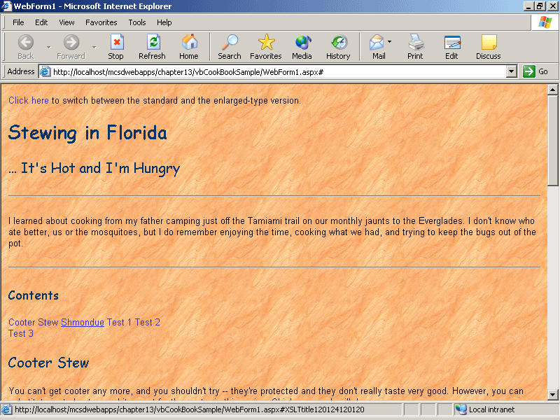
Figure 13-22. The cookbook sample
To perform the sample XSL transformation
- Using the same Web form from Exercises 1 and 2, delete the sample text you used to test style sheets. Retain the hyperlink and client-side script you created in Exercise 2.
- Add an XML server control after the hyperlink, as shown in the following HTML:
- <a onclick="SwitchSheets" href="#">Click here</a> to switch between the
- standard and the enlarged-type version.
<asp:Xml id="XmlTransform" runat="server" DocumentSource="" TransformSource="" />
- Copy the cook.xml and cook.xsl sample files to your project directory.
- Set the XML control’s DocumentSource property to cook.xml and TransformSource property to cook6.xsl.
- Display the Web form in the browser to confirm that the XML transformation works correctly.
Exercise 4: On Your Own
Think about ways to apply XML with XSL transformations to data that you currently present on the Web with HTML. Using XML to label content is a much more conceptual task than using HTML directly to format content, and it takes some getting used to. Perhaps the best way to learn is to try it on your own, using real-world data that you’re familiar with, as described in the following steps:
- Choose a simple project, such as an order form or an address list, and then create a sample XML file based on that data.
- Create an XSL file that contains templates to transform the XML file into HTML.
- Create a Web form that uses an XML control to perform the transformation.
- As you work, think about the following questions:
  - How do you determine the node hierarchy?
  - What are the advantages of creating collections within the hierarchy? For example:
  - <items>
  - <item>Item 1</item>
  - <item>Item 2</item>
</items>
  - How does writing XML leverage your database and object-oriented programming skills?
Review
The following questions are intended to reinforce key information presented in this chapter. If you are unable to answer a question, review the appropriate lesson and then try the question again. Answers to the questions can be found in the appendix.
- What is the advantage of using CSS rather than in-line styles for formatting a Web application?
- Why would you create a style for a class rather than for an HTML element?
- How do CSS and XSL relate to each other when it comes to formatting a Web application?
- What are the differences between HTML and XML?

